Activity 3:

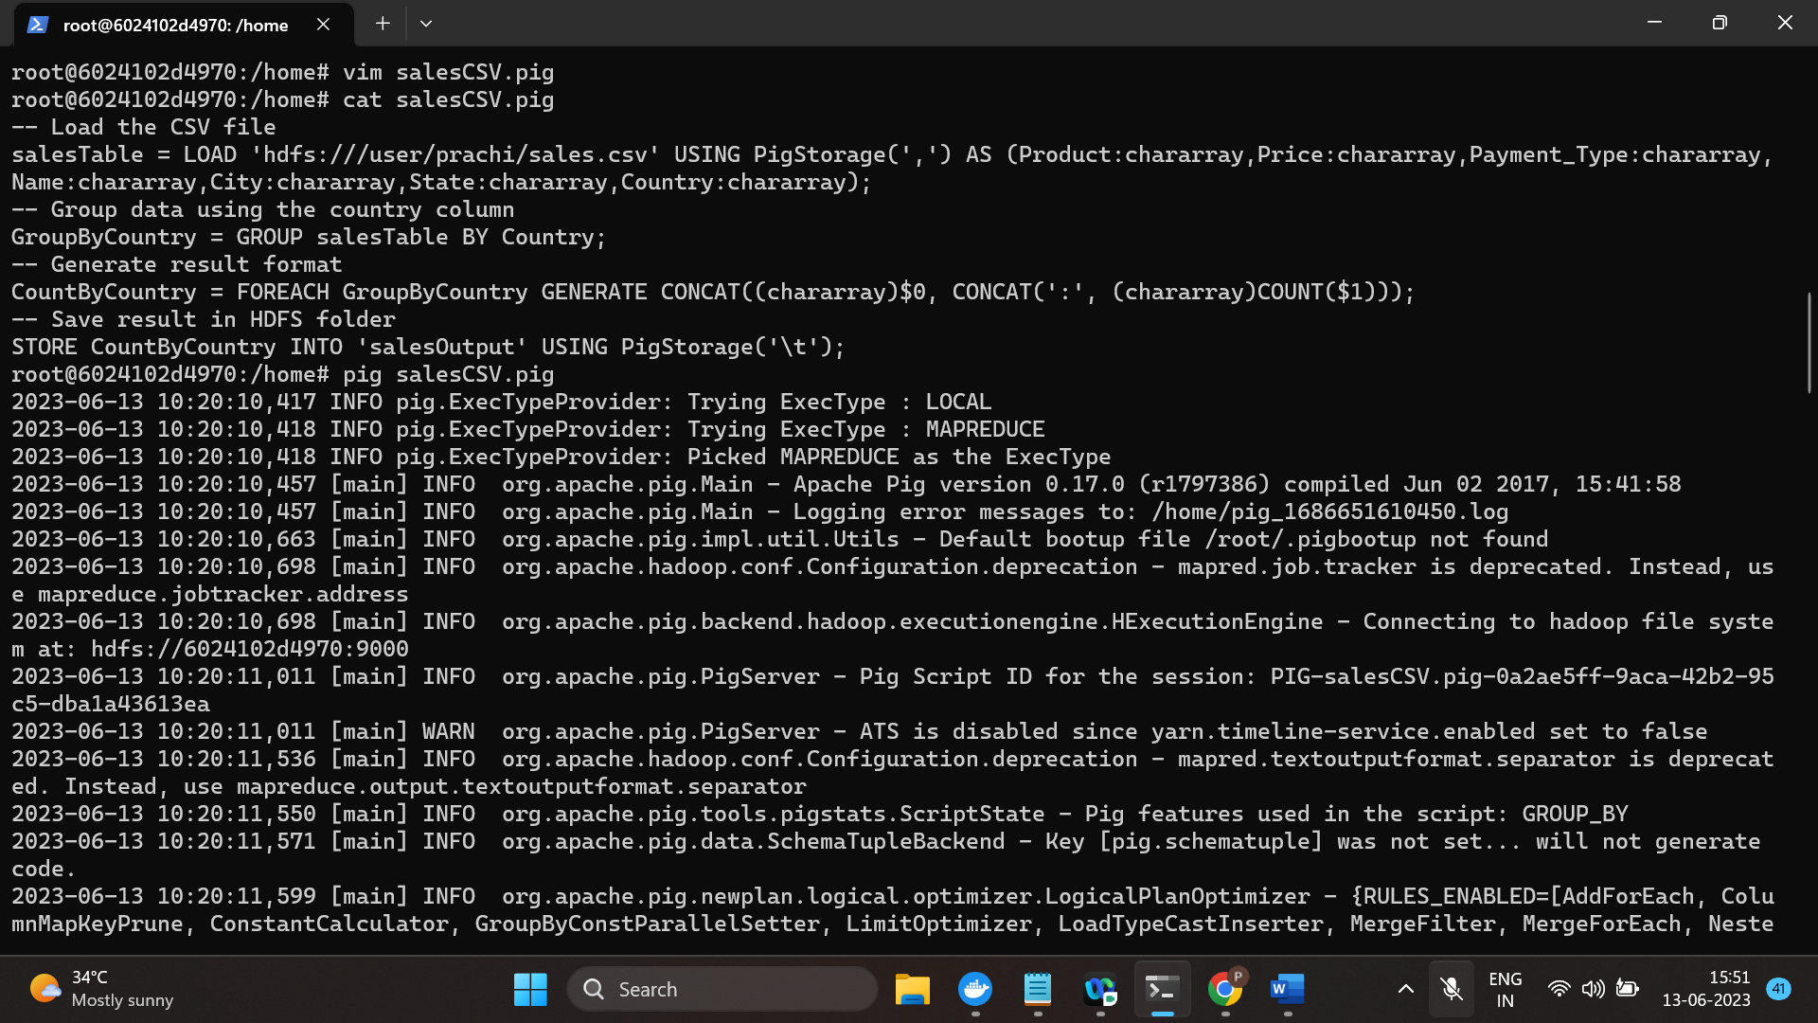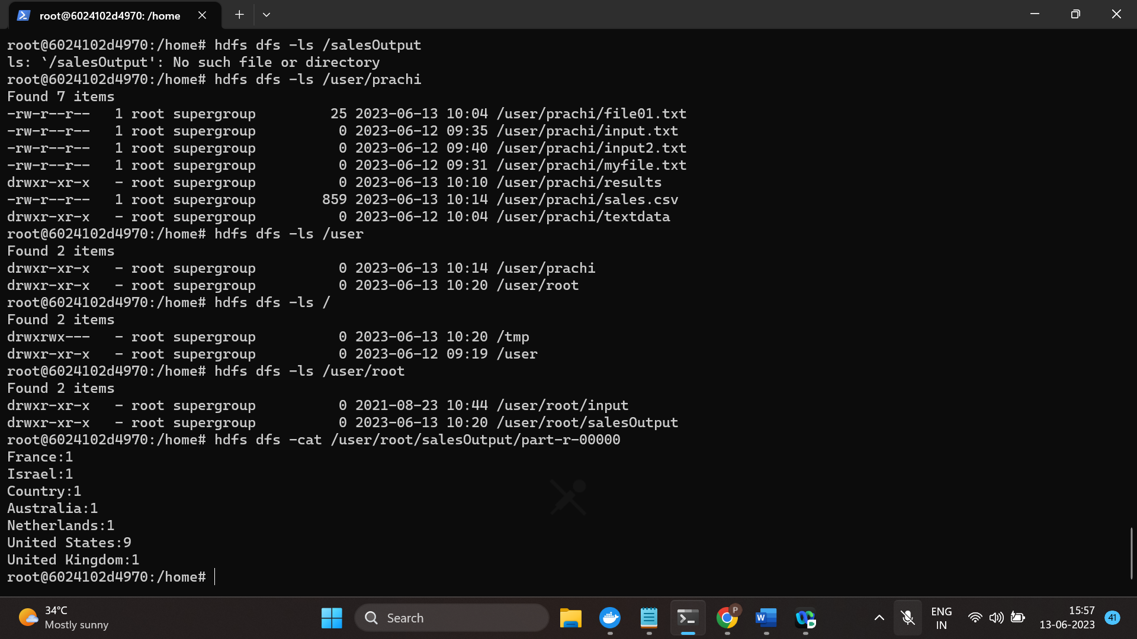

Result shown